**Simple Sales Data Visualization**

**Name: Gitika Pal**

**Unique ID: 202401100300112**

**Branch: CSE(AI)**

**Subject: Introduction to AI**

**Subject Code: AI101B**

**Simple Sales Data Visualization**

**Introduction**

In today's competitive business environment, companies must make data-driven decisions to remain profitable and efficient. Sales data is one of the most critical metrics in understanding business performance, allowing companies to track revenue, monitor product success, and optimize inventory management. However, raw sales data can be overwhelming and difficult to interpret, especially when dealing with large datasets.

To overcome this challenge, businesses use **data visualization** techniques to present information in an easy-to-understand graphical format. Visualization tools help in spotting trends, identifying best-selling products, and making informed business strategies. This report focuses on a **Simple Sales Data Visualization** tool that allows users to input sales data and generates a **bar chart** to display revenue distribution among different products.

## ****Problem Statement****

Businesses often struggle with managing and analyzing their sales data effectively. Some common challenges include:

* **Data Overload:** Manually analysing large amounts of sales data can be time-consuming and prone to errors.
* **Lack of Insights:** Without proper visualization, it becomes difficult to identify sales trends and key revenue contributors.
* **Decision-Making Challenges:** Business owners and managers need quick access to meaningful insights to make strategic decisions.
* **Complexity of Advanced Tools:** Many data analysis tools require technical expertise, making it difficult for small business owners or non-technical users to leverage their benefits.

This project aims to address these challenges by developing a **simple and user-friendly** sales data visualization tool that automatically processes user input and generates a bar chart for easy interpretation.

## ****Methodology****

To achieve the objectives, we implemented the project using **Python**, a widely used programming language for data analysis and visualization. The following steps outline the approach used to solve the problem:

### ****1. Data Collection****

* The program prompts users to enter the number of sales records they want to input.
* For each record, users provide:
  + **Product Name** (to identify the item sold)
  + **Units Sold** (to determine the quantity of items sold)
  + **Revenue** (to measure the financial contribution of each product)

### ****2. Data Processing****

* The collected data is stored in a **Pandas DataFrame**, a data structure commonly used for handling tabular data.
* This structured format allows easy manipulation and retrieval of information.

### ****3. Data Visualization****

* The **Matplotlib** library is used to generate a **bar chart**, where:
  + The **x-axis** represents the product names.
  + The **y-axis** represents the revenue generated by each product.
* The chart is customized with labels, a title, and color enhancements for better readability.

### ****4. Output & Analysis****

* The program prints a tabular representation of the sales data, allowing users to verify their input.
* The generated **bar chart** visually presents the revenue distribution, making it easier to compare product performance.

## ****Implementation****

The project was implemented using **Python** with two essential libraries:

* **Pandas:** For data handling and manipulation.
* **Matplotlib:** For generating the visualization.

The program follows a **user-input-driven approach**, where users enter their sales data interactively. After processing, a bar chart is displayed, providing an intuitive visual representation of revenue trends.

**Code**

import matplotlib.pyplot as plt

import pandas as pd

# Get sales data from user

num_entries = int(input("Enter number of entries: "))

data = {'Product': [], 'Units Sold': [], 'Revenue': []}

for i in range(num_entries):

    product = input(f"Enter product name for entry {i+1}: ")

    units_sold = int(input(f"Enter units sold for {product}: "))

    revenue = float(input(f"Enter revenue for {product}: "))

    data['Product'].append(product)

    data['Units Sold'].append(units_sold)

    data['Revenue'].append(revenue)

# Convert data to DataFrame

df = pd.DataFrame(data)

# Create a bar chart

plt.figure(figsize=(8, 5))

plt.bar(df['Product'], df['Revenue'], color='skyblue')

# Add labels and title

plt.xlabel('Products')

plt.ylabel('Revenue')

plt.title('Sales Data Visualization')

# Show the plot

plt.show()

# Print sales data

print(df)

**Output**

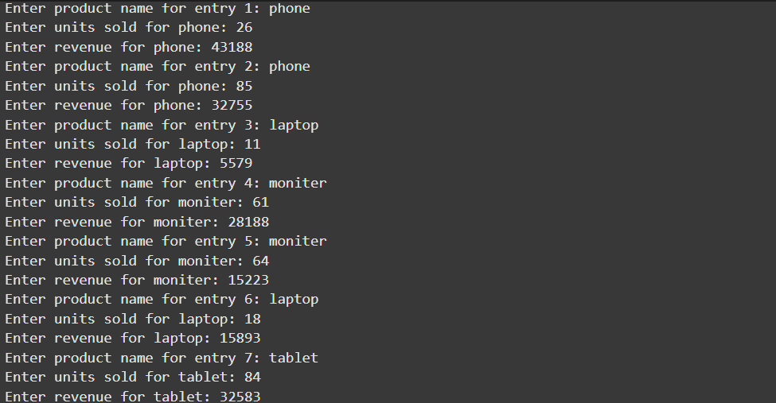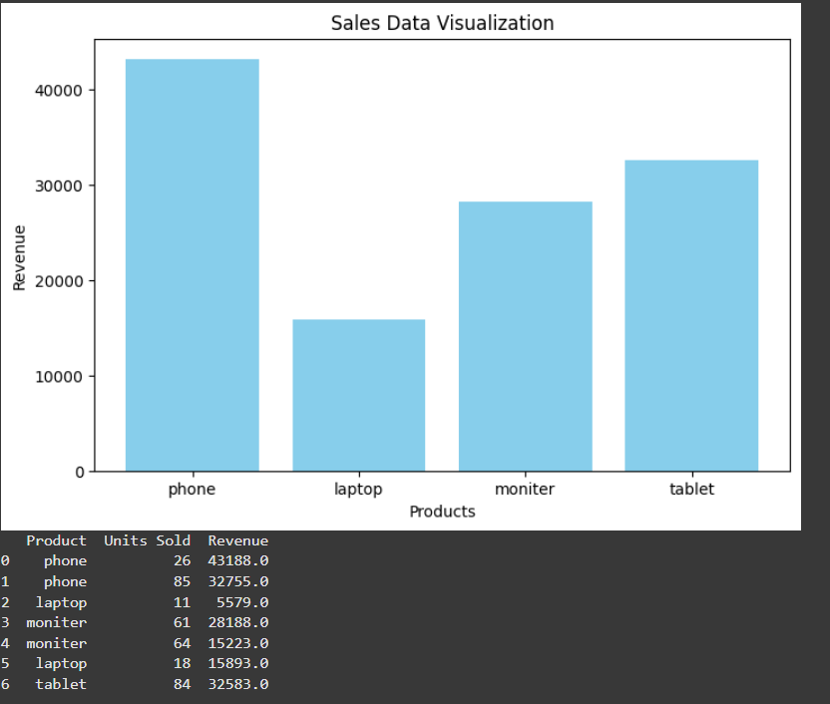

## ****Conclusion****

The **Simple Sales Data Visualization** tool provides a straightforward way to analyze sales data, offering both tabular representation and visual insights. By leveraging Python’s Pandas and Matplotlib libraries, the project simplifies the process of data collection, processing, and visualization.

### ****Future Enhancements****

While this tool serves as a basic implementation, future improvements could include:

* **Integration with Databases:** To automatically fetch sales data instead of manual input.
* **Multiple Visualization Options:** Such as pie charts or line graphs for more detailed analysis.
* **Export Features:** Allowing users to save reports as PDFs or Excel files.
* **Real-Time Data Updates:** Connecting to an online sales database for live tracking.

By implementing these enhancements, the tool can be further developed into a more advanced and automated sales analysis system.